Title: Streamlining Data Management: Implementing Time to Live (TTL) in AWS DynamoDB

Introduction:

In AWS DynamoDB, managing data lifecycle can be simplified with the Time to Live (TTL) feature. By enabling TTL, you can automate the removal of expired data from your DynamoDB tables, reducing storage costs and improving query performance. In this blog post, we will explore the steps involved in implementing Time to Live in AWS DynamoDB. Let's dive in!

Step 1: Access the DynamoDB Console Log in to the AWS Management Console and navigate to the DynamoDB service. This is where you can manage your DynamoDB tables.

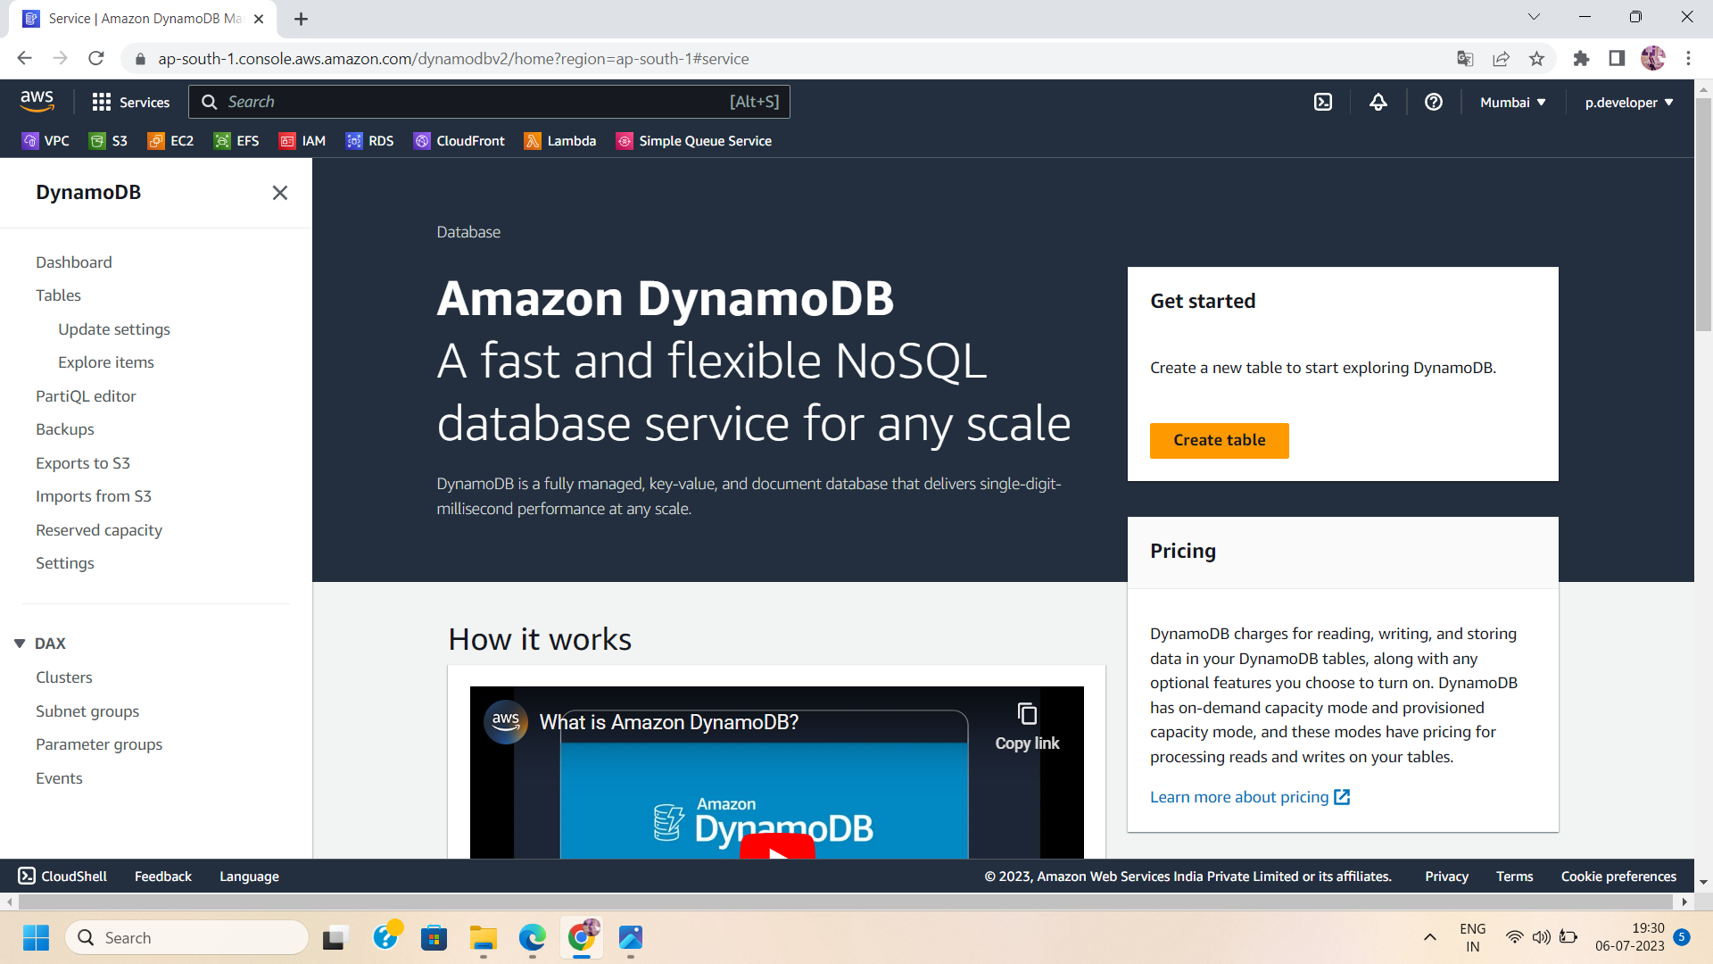

Step 2: Select the Desired Table From the DynamoDB console, choose the table for which you want to enable Time to Live or create a new table. Ensure that the table contains the data you want to manage with TTL.

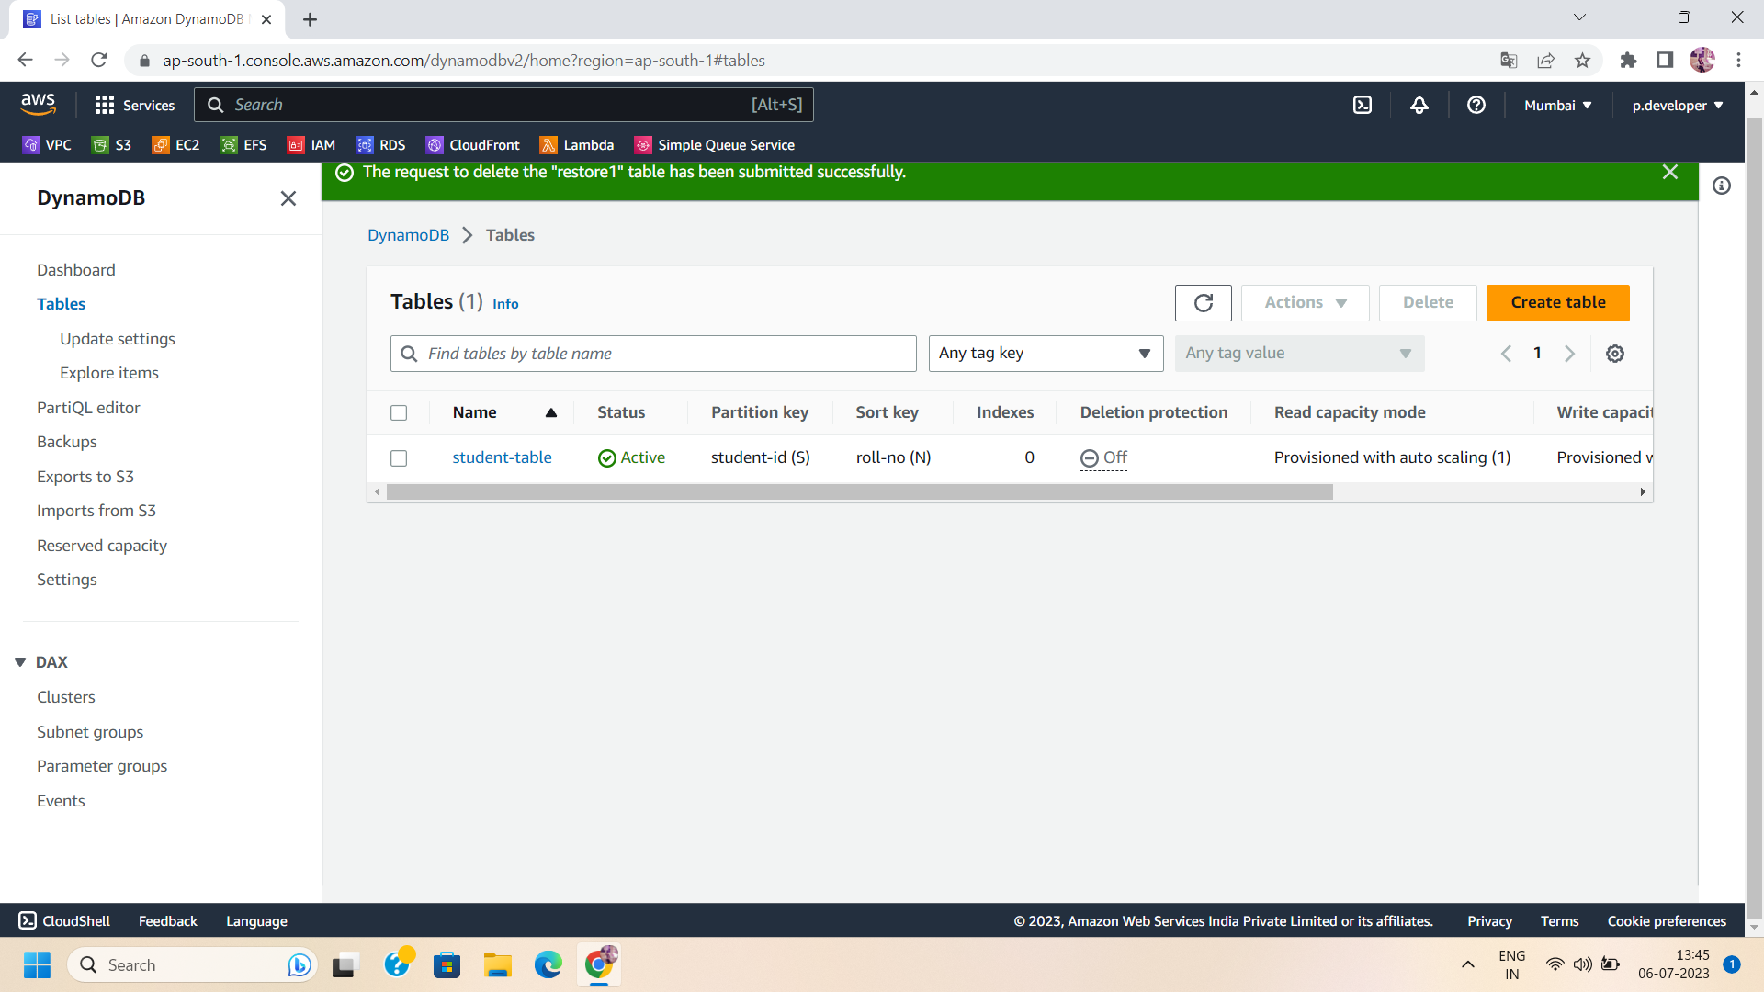

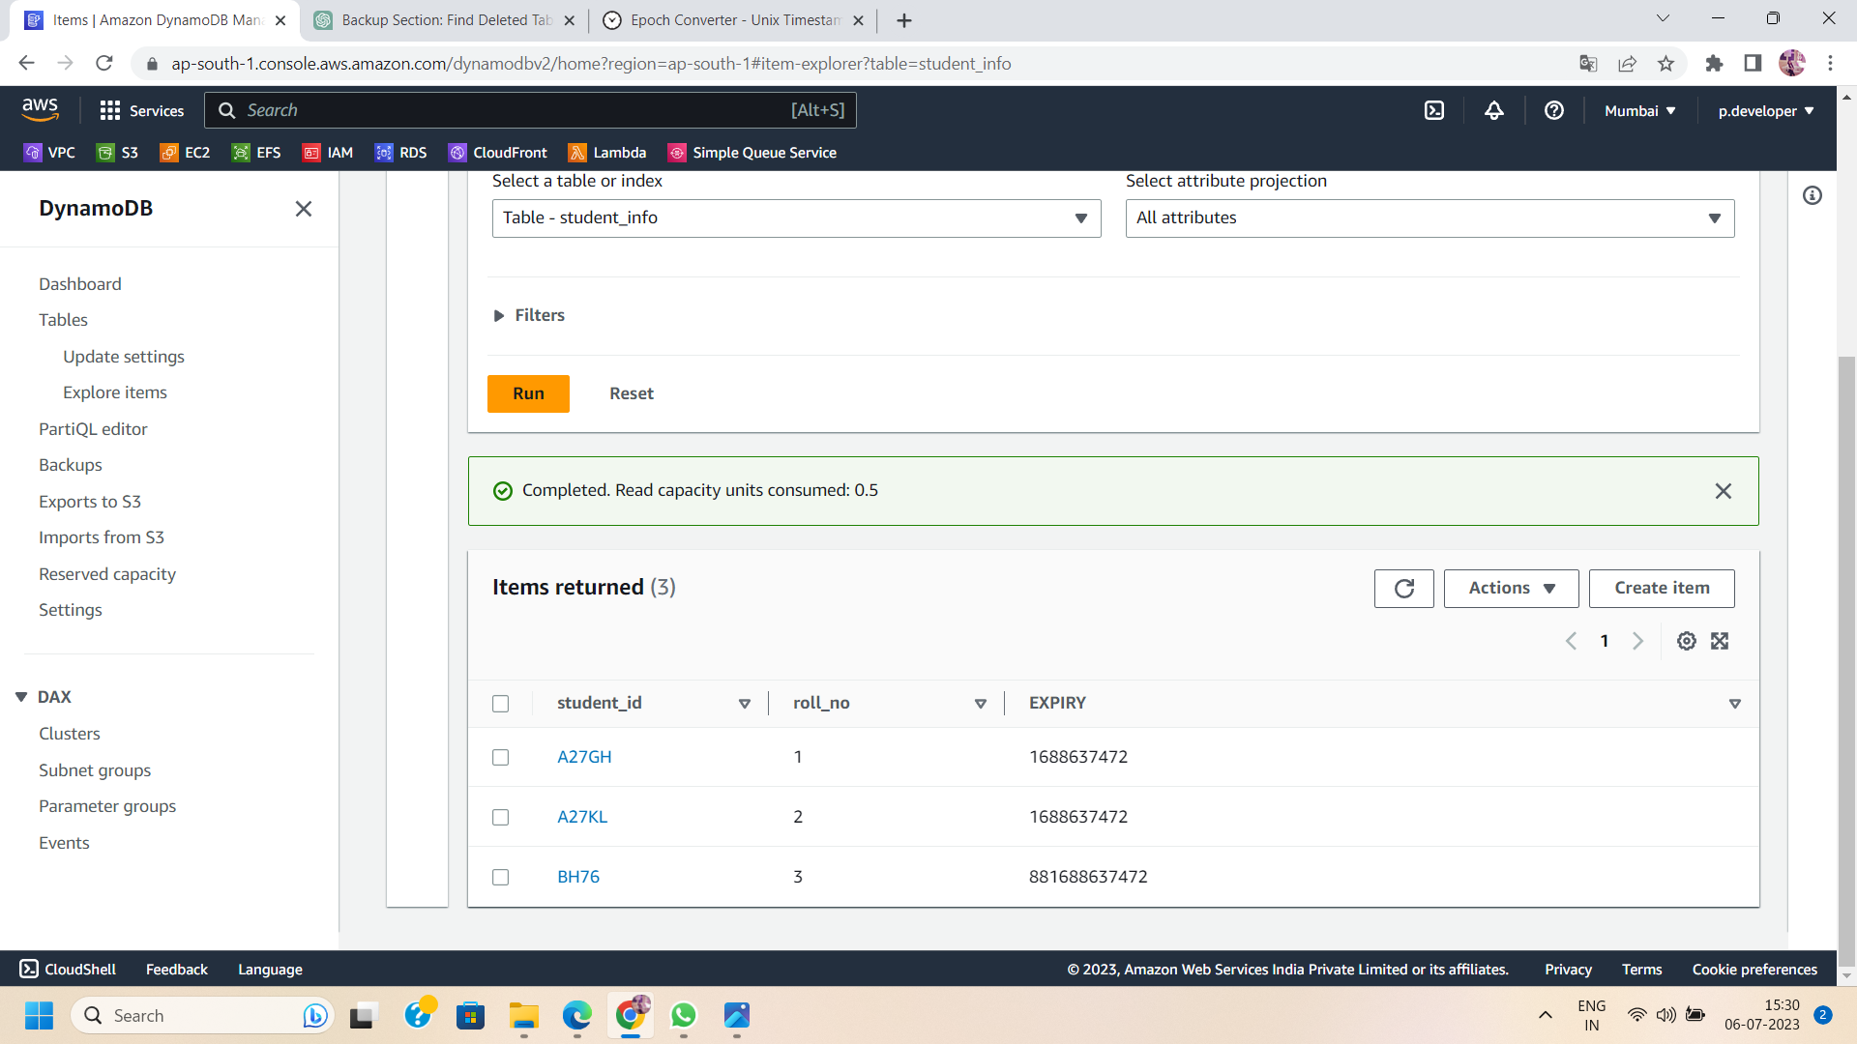

Step 3: Open Table Settings In the table overview, click on the "Additional Setting" button to access the Time to Live settings for the selected table.

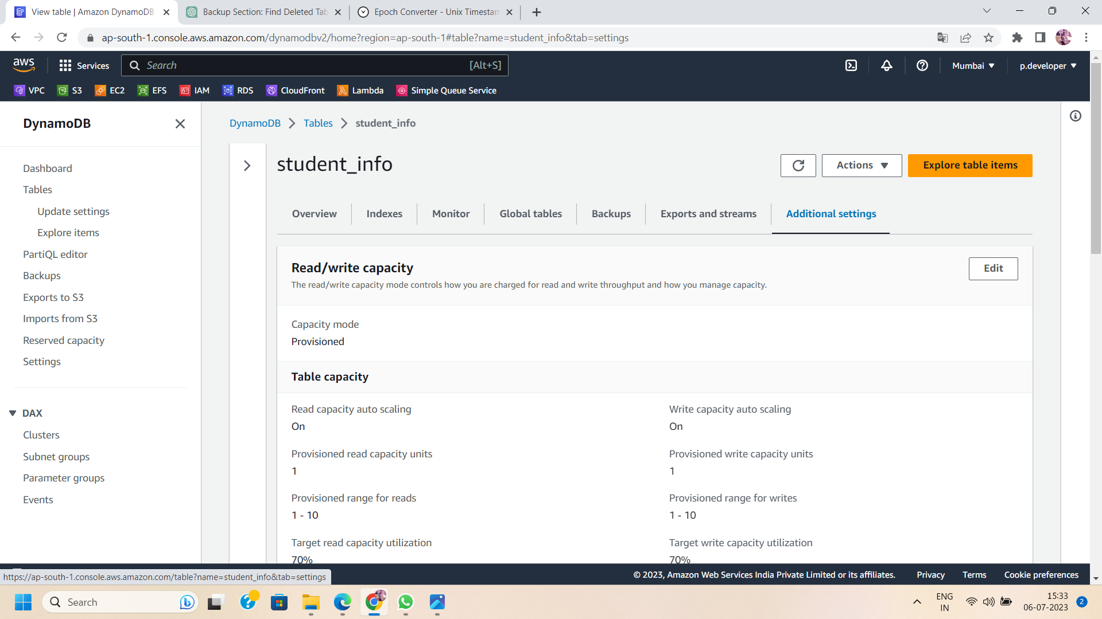

Step 4: Enable TTL Within the TTL settings, toggle the "Enable Time to Live" option to activate the feature for the chosen table. Enabling TTL allows you to specify a TTL attribute that determines when data expires.

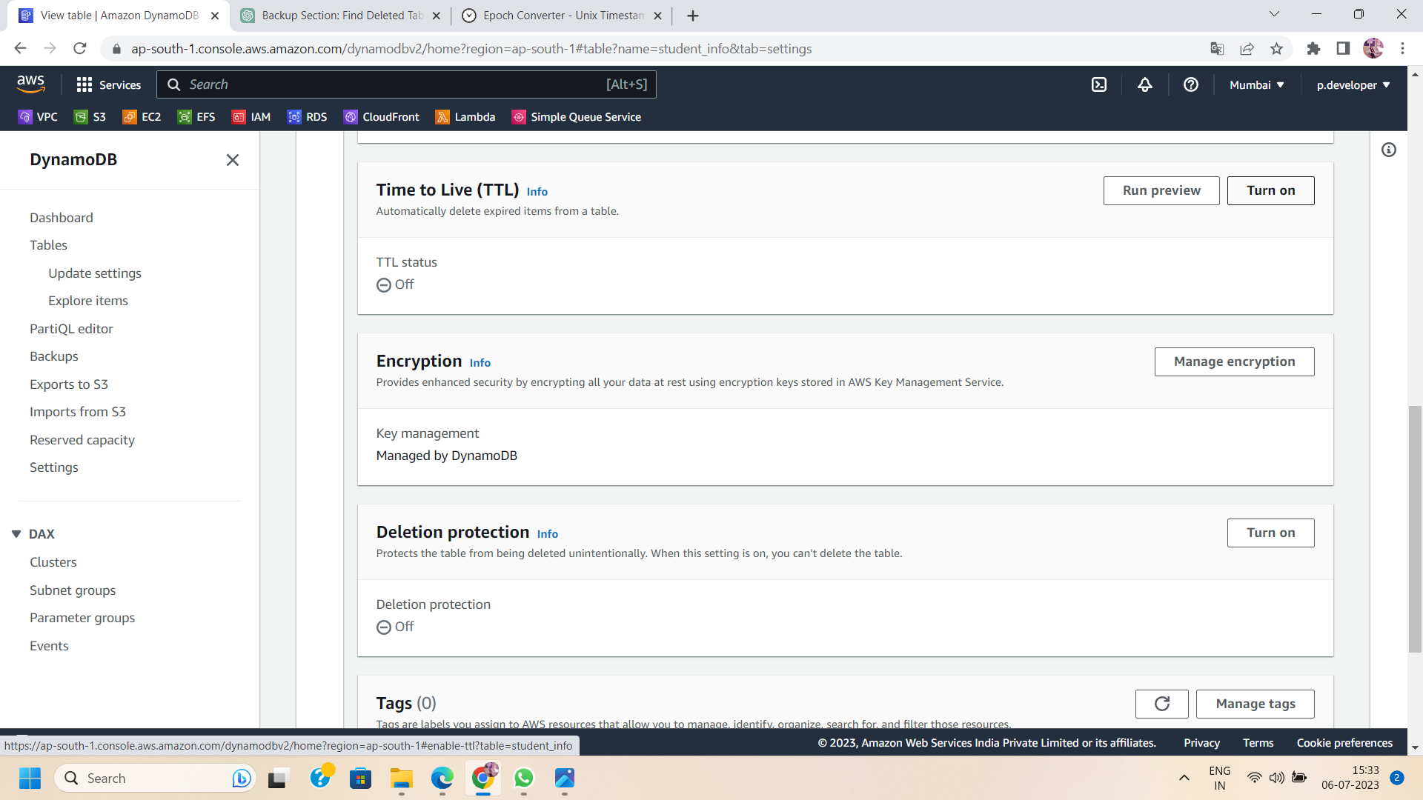

Step 5: Specify the TTL Attribute Specify the attribute in your table that will be used for TTL. This attribute should contain a Unix timestamp or an expiration date. DynamoDB will automatically remove the data records when the TTL attribute value exceeds the current time.

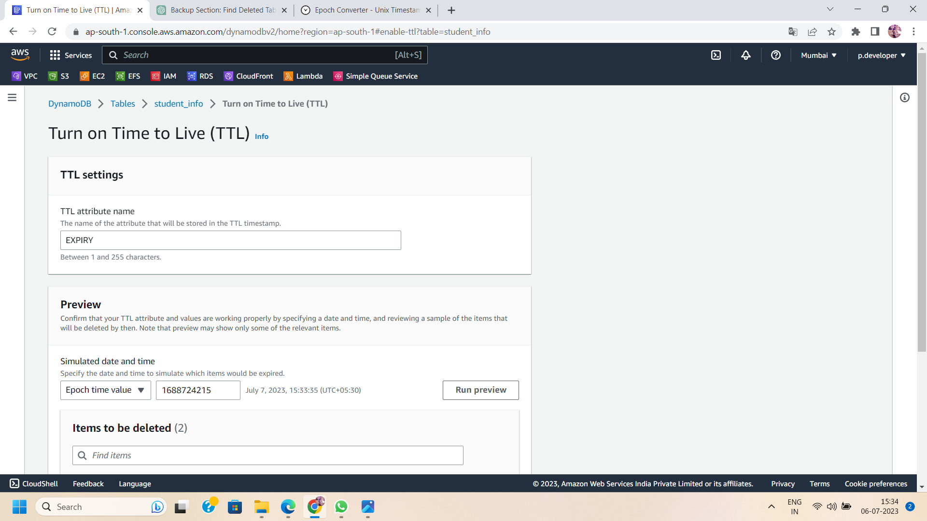

Step 6: Configure the Expiration Period Set the expiration period for your data records. This is the amount of time after which the data will be removed. You can specify the expiration period in seconds or as an absolute time in Unix timestamp format.

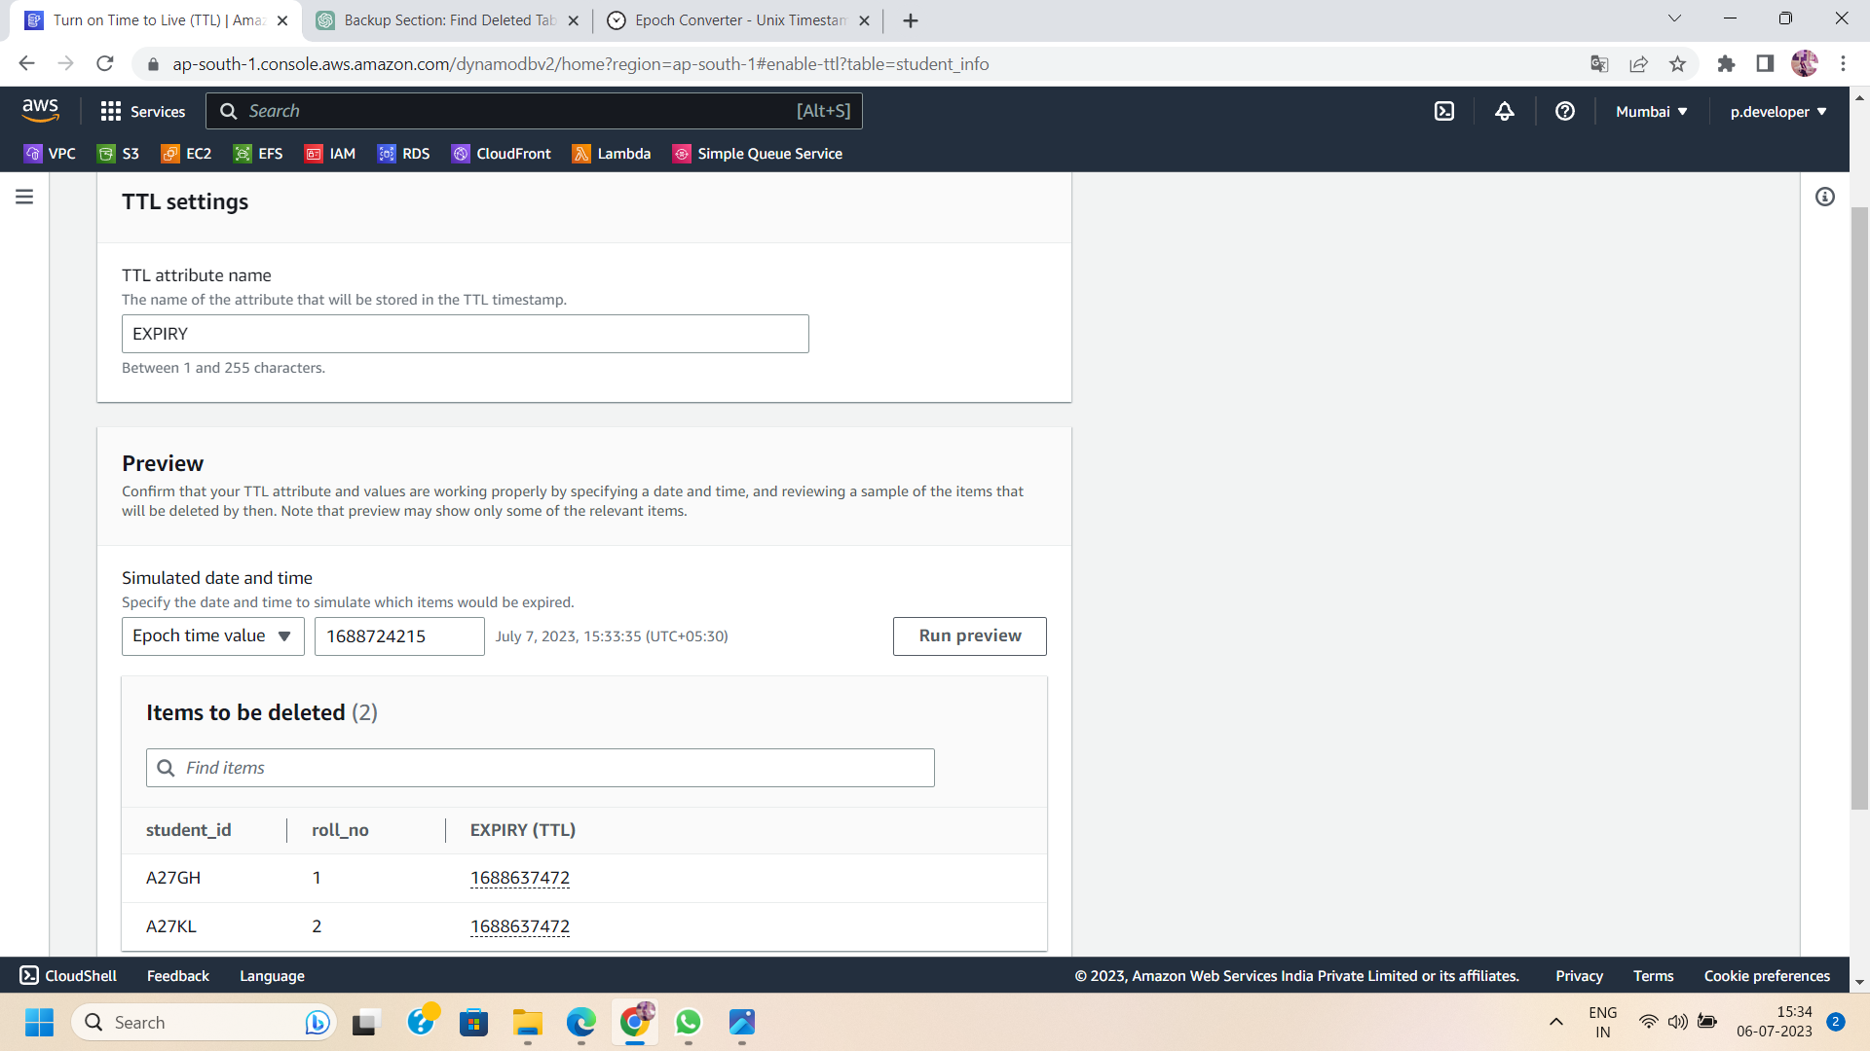

Step 7: Save the TTL Settings Once you have configured the TTL attribute and expiration period, save the settings. DynamoDB will automatically start managing the data removal process based on the specified TTL attribute.

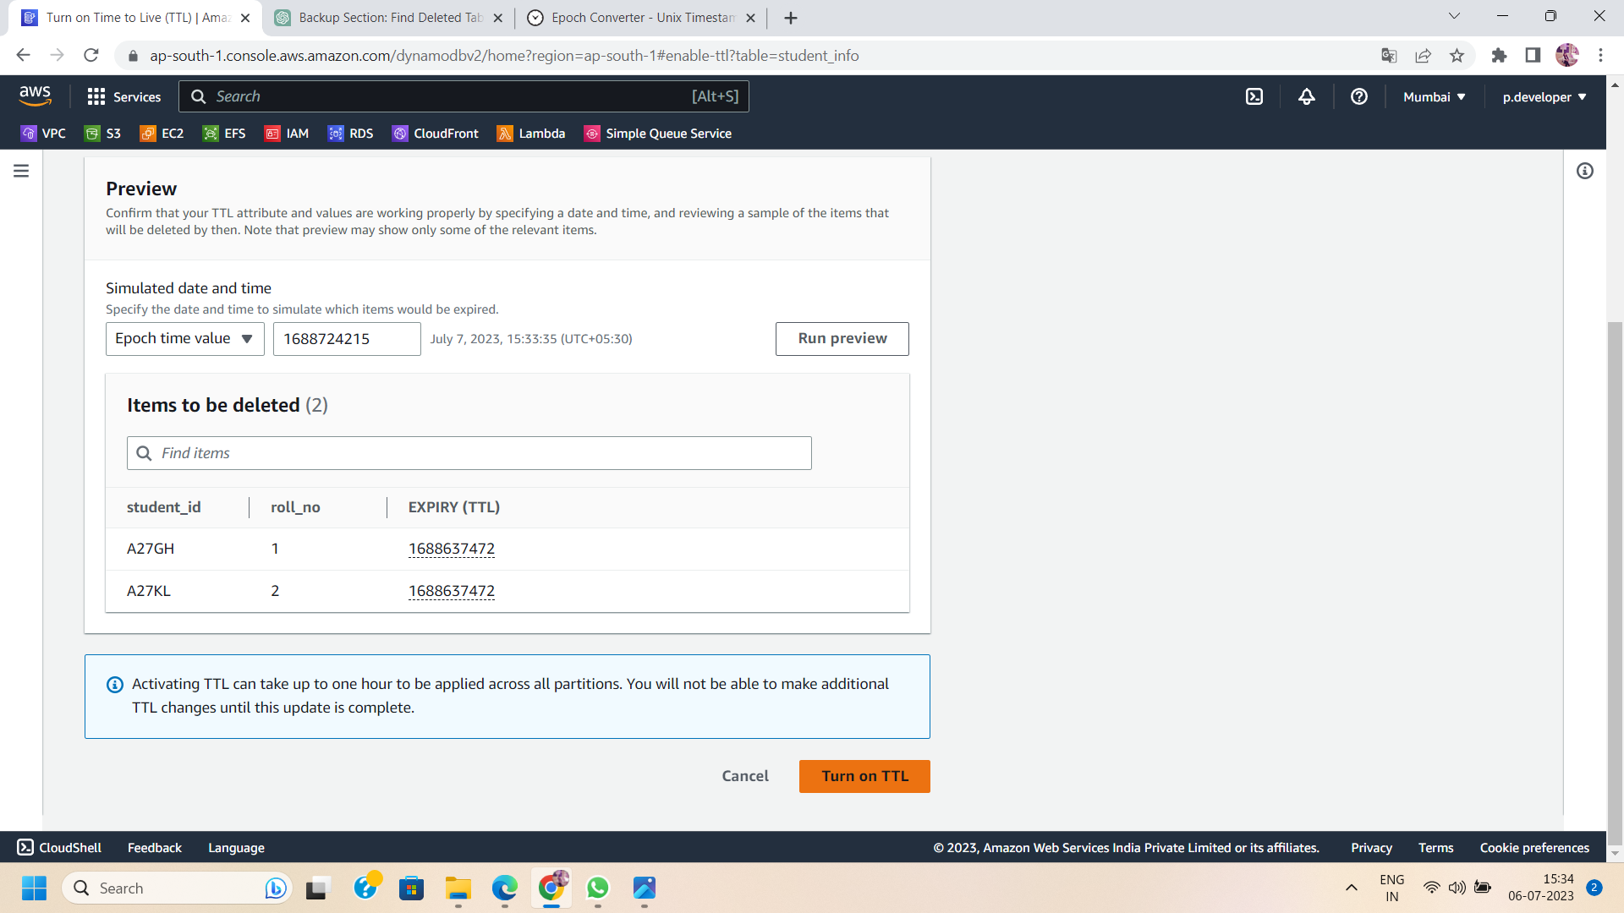

Step 8: Monitor and Verify TTL Expirations :

You can monitor the TTL process in the DynamoDB console to verify that expired data is being removed from your table. DynamoDB provides visibility into the expiration status and helps you ensure the efficient management of your data lifecycle.(e.g.,here roll_no 1 and roll_no 2 get deleted as they expired).

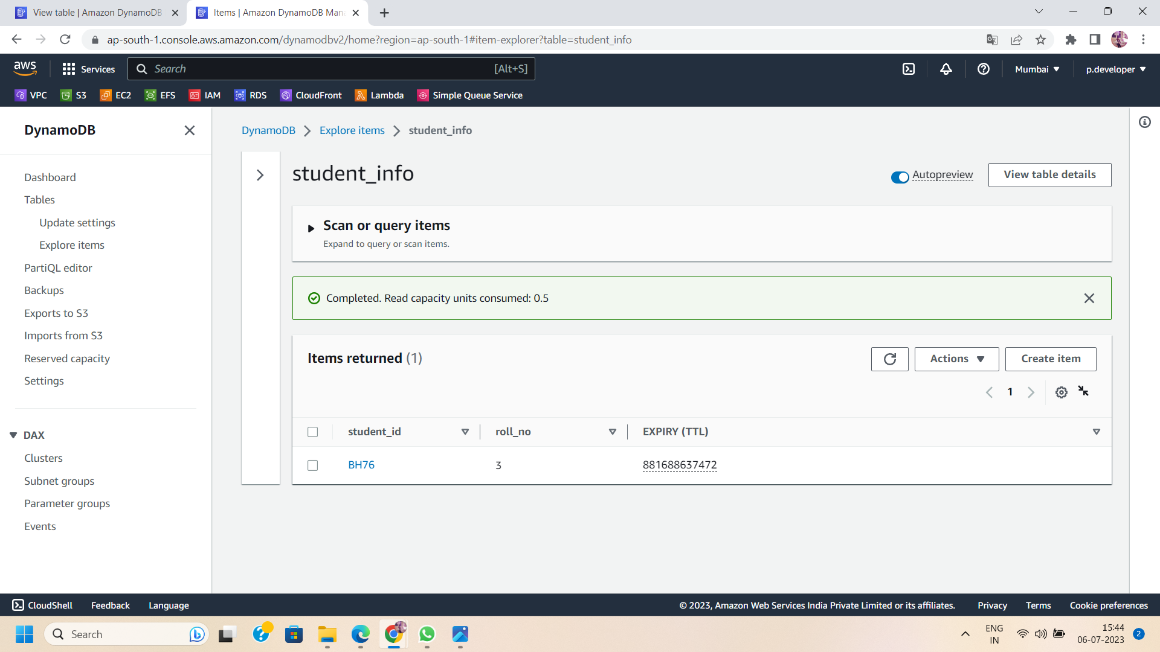

Conclusion:

Implementing Time to Live (TTL) in AWS DynamoDB simplifies data management and reduces storage costs by automating the removal of expired data. By following the steps outlined in this blog post, you can enable TTL for your DynamoDB tables and streamline your data lifecycle process. Embrace the power of TTL to optimize query performance, improve cost efficiency, and ensure your DynamoDB tables remain efficient and clutter-free. Simplify your data management with AWS DynamoDB's Time to Live feature and focus on the data that truly matters to your application.